**From:** Tony Martinez   
**Sent:** Friday, May 28, 2021 8:36 AM  
**To:** 'Palos Township Highway Dept'   
**Subject:** RE: easement

Good Morning April,

What would you like me to take up with the County? The township that the property lies on will need to evaluate and determine how it will be rectified.

This isn’t Orland Park property. I’m only making it known that once this last property is built and a fence is installed there will be no easement for access and that’s when service will stop.

**Tony Martinez |** AssistantPublic Works Director

Village of Orland Park

**From:** Palos Township Highway Dept   
**Sent:** Friday, May 28, 2021 8:28 AM  
**To:** Tony Martinez   
**Subject:** easement

This is what our attorney uncovered.  Maybe you can take it up with Cook County??

April Schrader

Assistant to Gene Adams

Palos Township Highway Commissioner

708-598-4451

**From:** Palos Township Highway Dept   
**Sent:** Thursday, May 27, 2021 2:44 PM  
**To:** Tony Martinez   
**Subject:** RE: Woodland Shores Pond Easement/ Access Point for Pond Services

He did some research. I will ask him what he came up with.

April Schrader

Assistant to Gene Adams

Palos Township Highway Commissioner

708-598-4451

**From:** Tony Martinez   
**Sent:** Thursday, May 27, 2021 2:26 PM  
**To:** Palos Township Highway Dept   
**Subject:** RE: Woodland Shores Pond Easement/ Access Point for Pond Services

Hi April,

Any updates on this?

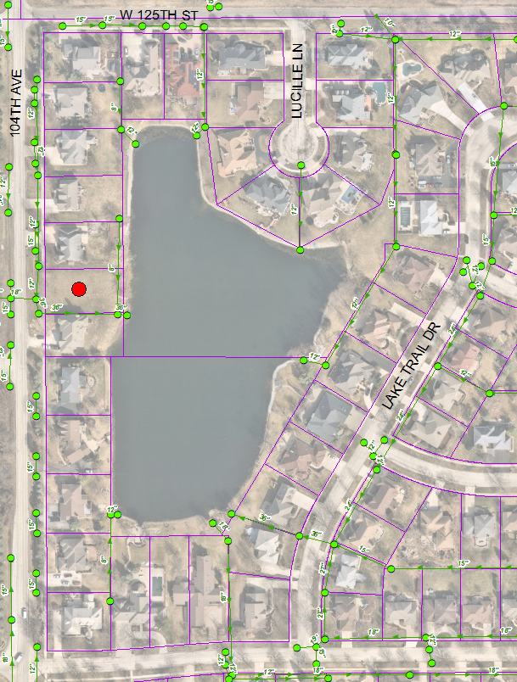

**Tony Martinez |** AssistantPublic Works Director

Village of Orland Park

**From:** Palos Township Highway Dept   
**Sent:** Thursday, May 13, 2021 9:35 AM  
**To:** Tony Martinez

**Subject:** RE: Woodland Shores Pond Easement/ Access Point for Pond Services

I’ll mention it. He’s out of the office in a meeting today

April Schrader

Assistant to Gene Adams

Palos Township Highway Commissioner

708-598-4451

**From:** Tony Martinez   
**Sent:** Thursday, May 13, 2021 9:04 AM  
**To:** Palos Township Highway Dept   
**Subject:** RE: Woodland Shores Pond Easement/ Access Point for Pond Services

Received. Can’t Palos Township initiate eminent domain?

**Tony Martinez |** AssistantPublic Works Director

Village of Orland Park

**From:** Palos Township Highway Dept   
**Sent:** Thursday, May 13, 2021 8:47 AM  
**To:** Tony Martinez   
**Subject:** FW: Woodland Shores Pond Easement/ Access Point for Pond Services

This is the email conversation between Building and Zoning and myself

April Schrader

Assistant to Gene Adams

Palos Township Highway Commissioner

708-598-4451

**From:** Ian Freimuth (Building and Zoning  
**Sent:** Tuesday, May 11, 2021 9:31 AM  
**To:** Palos Township Highway Dept   
**Subject:** Re: Woodland Shores Pond Easement/ Access Point for Pond Services

It would be very difficult.  Very few homeowners would want to volunteer their property for heavy equipment access.  Normally in cases where there's a common element, the property near the affected element will be disturbed.  Such as a bulkhead or drain that is adjacent to that property.  For something more remote, that becomes an issue.

I have no idea why this subdivision wasn't planned with some sort of public access away.

**From:** Palos Township Highway Dept   
**Sent:** Tuesday, May 11, 2021 9:25 AM  
**To:** Ian Freimuth (Building and Zoning)   
**Subject:** RE: Woodland Shores Pond Easement/ Access Point for Pond Services

Thanks, I wonder how hard that is to do after the fact?

April Schrader

Assistant to Gene Adams

Palos Township Highway Commissioner

708-598-4451

**From:** Ian Freimuth (Building and Zoning)   
**Sent:** Tuesday, May 11, 2021 8:55 AM  
**To:** Palos Township Highway Dept   
**Subject:** Re: Woodland Shores Pond Easement/ Access Point for Pond Services

Hi April,

They will not be able to service the pond unless some sort of easement agreement is reached with private property owners.

This situation is unfortunate.

**From:** Palos Township Highway Dept   
**Sent:** Tuesday, May 11, 2021 8:50 AM  
**To:** Ian Freimuth (Building and Zoning)   
**Subject:** FW: Woodland Shores Pond Easement/ Access Point for Pond Services

Hi Ian, maybe you could weigh in on the situation below. I spoke with Tony from the Village of Orland Park.  They maintain the pond and storm sewers over there and are concerned about access once this last house is finished.

April Schrader

Assistant to Gene Adams

Palos Township Highway Commissioner

708-598-4451