**From:** Joel Van Essen   
**Sent:** Thursday, July 22, 2021 11:50 AM  
**To:** Greg Summers  
**Subject:** FW: Lake Lucille/Woodland Shore Agreements

Greg,

The image attached is for area outside our boundary.  Lisa recalculated just the two subdivisions and neighborhood east that tie into the pond and came up with 168 structures and 3.3 miles.

Joel

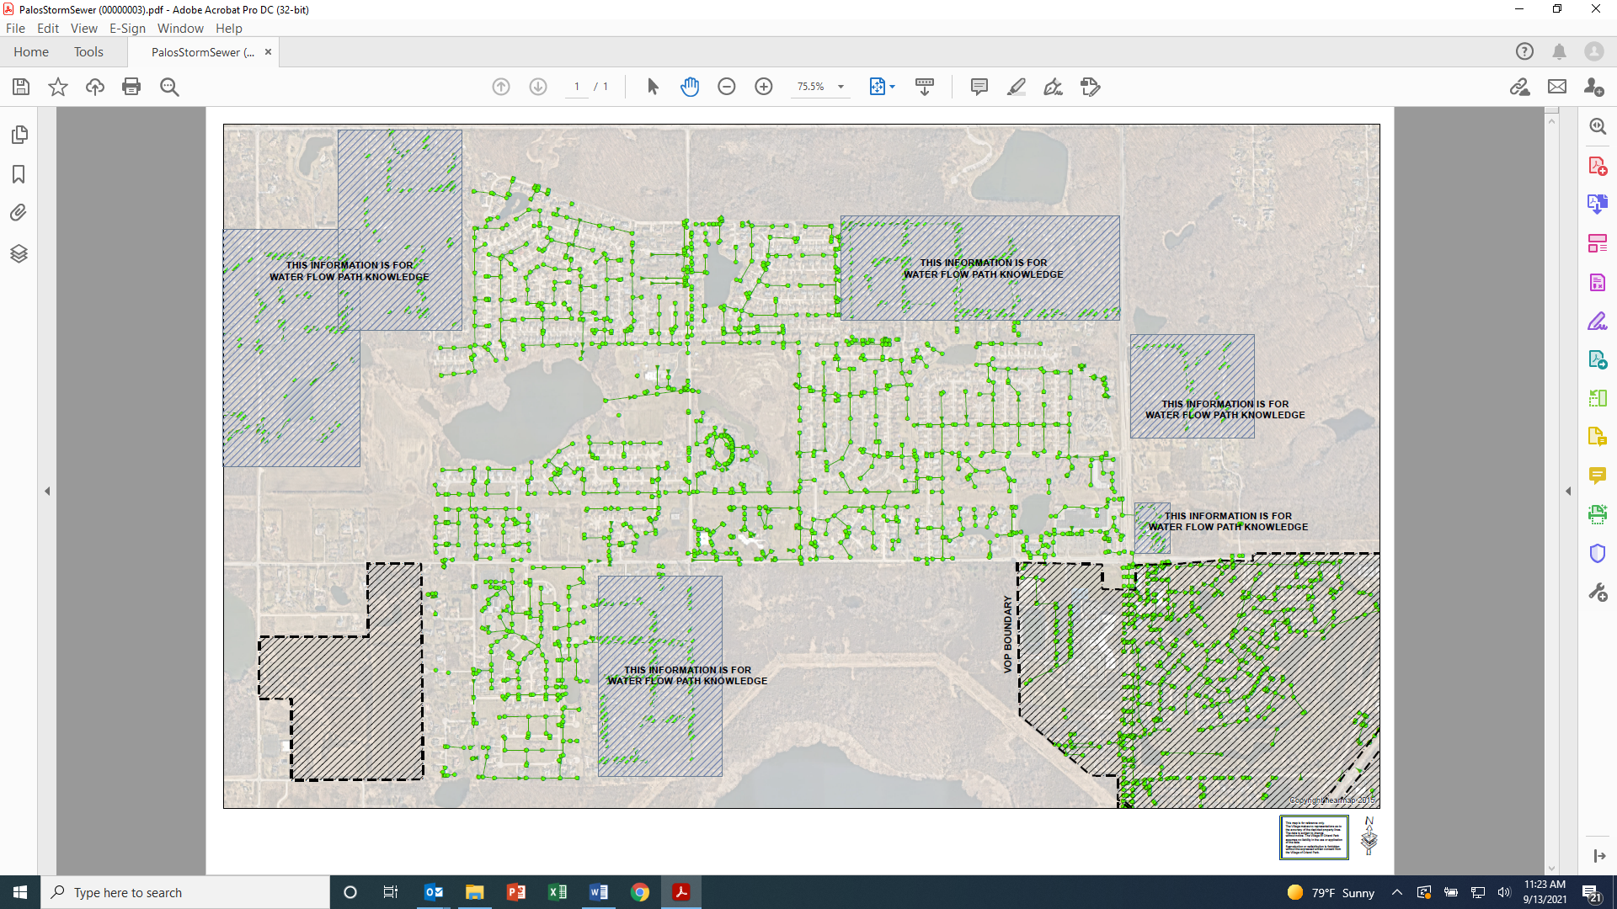

**From:** Greg Summers   
**Sent:** Wednesday, July 21, 2021 3:30 PM  
**To:** Joel Van Essen  
**Subject:** RE: Lake Lucille/Woodland Shore Agreements

How much storm sewer do we own/maintain before it gets to MWRD conveyance?

**Greg E. Summers, AICP** | Assistant Village Manager

Village of Orland Park

**From:** Terica Ketchum   
**Sent:** Wednesday, June 16, 2021 11:59 AM  
**To:** Lisa Gulczynski ; Joel Van Essen   
**Cc:** Ken Dado; Tony Martinez ; Joshua Burman; Michael Mazza   
**Subject:** RE: Woodland Shores Easement

Good afternoon,

Attached is a copy of the Subdivision Agreement, which was fully executed on March 31, 1989. According to the Agreement, the Village is responsible for the maintenance of the detention pond.

Pursuant to Paragraph 9. E., on page 7, the Village was to be paid  $7,500 to reimburse in part the Village for the cost of maintaining the retention/detention area. Pursuant to Paragraph 11, on page 8, the site constituting the storm water retention/detention area (Lot 18) was conveyed to the Village for agreeing to own and maintain the public improvements consisting of underground water mains and lines, fire hydrants, valves and appurtenances, and sanitary sewers and lines and appurtenances. The Village agreed to maintain Lake Lucille after the completion of the reconfiguration of Lake Lucille.

Thank you again, Lisa, for all of your research and assistance in this matter.

Sincerely,

Terica Ketchum

**Terica Ketchum** | Assistant to the Village Manager / Risk Manager

Village of Orland Park

**From:** Lisa Gulczynski   
**Sent:** Tuesday, June 15, 2021 3:38 PM  
**To:** Joel Van Essen   
**Subject:** Woodland Shores Easement

All –

I dug a little deeper into the Lake Lucille information. See attached plat of subdivision and Minutes of the Public Services and Engineering Committee from 1988. Note on the west side of the property between lots 6/7 & 8 there is a 15’ ingress and egress easement as was discussed in the meeting minutes in paragraph five under Lake Lucille. It also states no fences will be allowed on the perimeter of the lake and homeowners will maintain the property to the edge of the lake. The maintenance the Village would be ensuring is water flow. The attached “reference to agreement” is a document making reference to the legal firm of Ash, Anos, Freedman, and Logan that drafted the subdivision agreement. The agreement is not in the file and we could not locate it in Legistar. Based off of the other documents the agreement would have been between 1988-1989.

Documents DOC008 and DOC009 reference the Joint Venture Project regarding utilities to unincorporated Palos Township. DOC008 is the original agreement, DOC009 is the soon thereafter amendment after acquiring Lake Michigan water.

**Lisa Gulczynski** | Public Works GIS Tech

Village of Orland Park

**From:** Lisa Gulczynski   
**Sent:** Friday, June 11, 2021 4:28 PM  
**To:** Joel Van Essen   
**Cc:** Ken Dado ; Tony Martinez; Burman ; Michael Mazza   
**Subject:** RE: Woodland Shores Easement

Joel –

Attached is an overall map showing what we service outside the village boundary. It is predominately Palos, but we do service the Advocate in Tinley Park (Orland Parkway & LaGrange Rd). Within the Palos area there are 2 sanitary lift stations, 2 wet ponds, and 1 dry pond.

When we provide utility service outside of the village boundary (water, sanitary, and storm) we do not maintain roadways, right-of-ways, street lights, sidewalks, or parkway trees. Nor do we provide garbage service to unincorporated addresses. If we damage any other entity’s infrastructure due to a utility dig we do repair what we damaged.

The 131st St Lift Station is located at 10000 Creek Road. The Pinewood North Lift Station is located at 13617 McCabe Drive.

I have also attached maps (below) for the ponds in the Palos area that we maintain. Below is the available information for the pond/lift station parcels from the Cook County Clerk’s Office website. When no data is returned it is typically due to the information being prior to Cook County digitizing records.

Site P28-01:

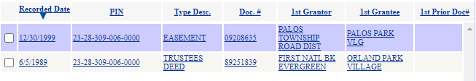

Site P28-02:

North Parcel

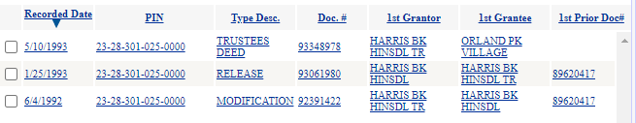

South Parcel

Returns no records on the Cook County Clerk’s Office website

Site P33-01:

Returns no records on the Cook County Clerk’s Office website

131st St Lift Station:

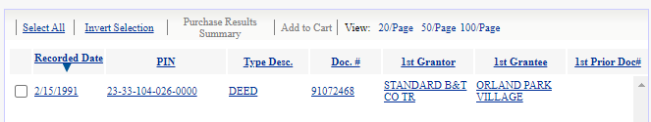

Pinewood North Lift Station:

Returns no records on the Cook County Clerk’s Office website

**Lisa Gulczynski** | Public Works GIS Tech

Village of Orland Park

