Woodland Shores/Lake Lucille Requests for Information to the Village of Orland Park

- Agreement referenced in Orland Park presentation on August 9, 2021, between Palos Township and Orland Park for maintenance of water, sanitary sewer, and storm services.
  - See previous provided information.

- Agreement whereby Orland Park received $7,500 for maintenance of each pond in Woodland Shores / Lake Lucille subdivisions in 1987.
  - See previous provided information.

- Records of all pond or Lake Lucille maintenance performed by Orland Park by date and description from 1987 to the present.
  - See web page for some old tickets as examples and a spreadsheet from our Computerized Maintenance Management System that we implemented in 2019. Pond inspections are not recorded as specific work tickets. Inspections include water quality issues and storm inlet/outlet obstructions and removal.
  - At town hall meeting it was noted that subdivision residents also inspect, treat the pond water, and remove obstructions.
  - While the questions ask about maintenance for the two subdivisions, funds are a corporate account so maintenance funds are used throughout the system. There are other structures and equipment in the systems that include lift stations, booster stations, meters, valves, fire hydrants, water towers, dams, reservoirs, a main pump station. All these also require maintenance and repair each year.
  - The current water, sewer, and storm systems in Lake Lucille / Woodland Shores are approximately (30) thirty years old. This is considered mid-range for age and as they age more, more repair work will be forthcoming similar to other infrastructure repairs.

- Records of all equipment needed or used to service ponds in Woodland Shores / Lake Lucille subdivisions and access easement.
  - See web page for Utilities vehicles and equipment. This is also a cost that has to be recapitalized each year with water funds.

- All capital maintenance budgets or statements for the Woodland Shores and Lake Lucille subdivisions.
  - See budgets from 2007-2021 on web page below.
  - https://orlandparkil.prod.govaccess.org/government/transparency-and-accountability/budget
  - See web page for capital projects request for the future.
  - Capital projects are throughout the Village because the water, sewer, and storm are paid through a corporate water rates. Being a corporate account across incorporated and unincorporated areas, funds previously or today may go to other areas other than Lake Lucille and Woodland Shores that are older to be repaired. In the future, other subdivision funds would be used in Lake Lucille and Woodland Shores work.

- The dates and amounts expended by Orland Park in installing the water, sanitary sewer, and storm sewer systems in Woodland Shores / Lake Lucille subdivisions.
  - See previous provided information.

- The amounts received by Orland Park from developers or other third parties for reimbursement for cost of installing the water, sanitary sewer, and storm sewer systems in Woodland Shores / Lake Lucille subdivisions.
  - See previous provided information.

- All documents showing any easements granted to Orland Park for access to Lake Lucille or any pond in Woodland Shores / Lake Lucille subdivisions.
  - See previous provided information.

- A list of all subdivisions outside of the corporate limits of Orland Park for which Orland Park provides water, sanitary sewer, or storm sewer services.
  - See web page for Service Area Map (orange locations).

- The fees received by Orland Park from Woodland Shores / Lake Lucille subdivision residents for water, sanitary sewer, and storm sewer services from 1987 to the present.
  - Our financial system does not allow us to pull reports by subdivision. It is per meter location and amount of usage.

- All documents referring or relating to any assessment issued or levied by Orland Park to Woodland Shores / Lake Lucille subdivisions, including calculations of any assessments, from 1987 to the present.
  - See previous provided information.

- All documents and calculations referring or relating to the proposed assessment in 2022 to be imposed by Orland Park on the Woodland Shores or Lake Lucille subdivisions as stated in the Village Manager’s letter dated July 26, 2021.
  - As noted in agreements, the subdivisions paid an initial maintenance fee of $7,500 for Lake Lucille and $15,000 for Woodland Shores. This fee was divided among the lots. For 30 years, this fee was not carried forward. This fee would be reassessed per residents and inflation would be factor for out years.

- Copies of the Metropolitan Water Reclamation District Requirements referenced in Paragraph Two of the Village Manager Letter dated July 26, 2021.
  - See previous provided information.
  - See web page for additional information of 2014 MWRD Ordinance.
  - See MWRD’s current Watershed Maintenance Ordinance on their website. https://mwrd.org/watershed-management-ordinance-and-infiltrationinflow-control-program.

- Identification and definition of all easement obstructions Orland Park claims “must be removed” in the Woodland Shores and Lake Lucille subdivisions as stated in the Village Manager’s letter dated July 26, 2021.
  - Obstructions to be removed as noted in letter that would hinder access with equipment to pond, along the edge of pond, or easements in other parcels.
    - Permanent structures like playground equipment/sheds, fences, patio pavers, decks, pools
    - Landscaping that obstructs or changes the flow of water to inlets that impact other residents or Village. Ex: Raised landscaping beds.

- All documents referring or relating to Orland Park’s ownership of Lake Lucille or any portions thereof.
  - See previous provided information.
  - In addition, a copy of a deed, document 93348978, that was recorded on 5/10/93 for Lot 18 from Harris Bank to Village of Orland Park. See screen shot below.
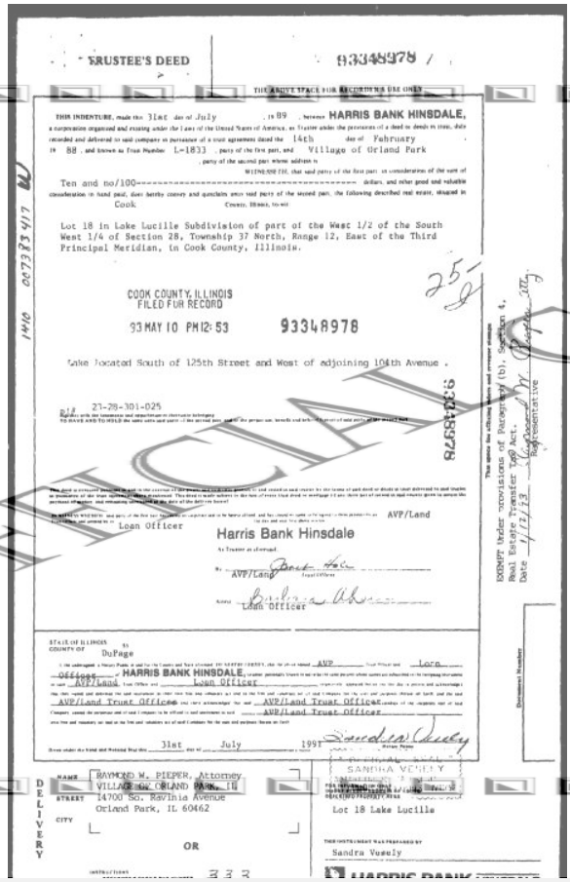

- All demands for removal of easement obstructions sent by Orland Park to any homeowner or subdivision from January 1, 2015, to the present.
  - Subdivisions include Grassland Subdivision, Vintage Crossing, Bluff Point, other individual homeowners.

- All documents, ordinances, or other legal authority supporting the assessment Orland Park intends to levy against Woodland Shores / Lake Lucille subdivision residents as stated in the Village Manager’s letter dated July 26, 2021.
  - See previous provided information.

- All documents, ordinances, calculations, or assessments supporting the water, sanitary sewer, and storm sewer rates charged to Woodland Shores and Lake Lucille residents by year from 1987 to the present.
  - See Water Rate Ordinance 4-3-1-2: Water and Sewer Service and Stormwater service charges outside of Corporate Limits. (https://codelibrary.amlegal.com/codes/orlandpark/latest/orlandpark_il/0-0-0-2938#JD_4-3-1-2)
  - See web page for rate study that determines rates.

- All communications with the Metropolitan Water Reclamation District, Army Corps of Engineers, Cook County, Palos Township, or any other governmental agency concerning Orland Park’s maintenance of the water, sanitary sewer, and storm sewer systems for the Woodland Shores / Lake Lucille subdivisions.
  - See question #36.

- All documents referring or relating to whether Lake Lucille is a “spring-fed, ”retention, or flow-through pond, or any alterations to Lake Lucille by Orland Park or any developer.
  - See previous provided information.

- All documents referencing or supporting the differences in water, sanitary sewer, and storm sewer fees or rates charged by Orland Park to unincorporated versus incorporated areas.
  - See Water Rate Ordinance 4-3-1-1: Water and Sewer and Stormwater service charges within corporate limits and 4-3-1-2: Water and Sewer Service and Stormwater service charges outside of Corporate Limits. (https://codelibrary.amlegal.com/codes/orlandpark/latest/orlandpark_il/0-0-0-2938#JD_4-3-1-2)
  - See webpage for ordinance changes.

- All accountings, budgets, or statements of water, sanitary sewer, and storm sewer fees received by Orland Park from residents of the Woodland Shores and Lake Lucille subdivisions.
  - See Question #10.

- Documents sufficient to show all capital maintenance charges imposed by Orland Park on any other homeowner or subdivision from January 1, 2015, to the present.
  - Capital projects are paid through water rates charges.

- All documents referring or relating to any watershed, shoreline restoration, or bas in shoreline management project proposed or developed by Orland Park for Lake Lucille.
  - See web page for the Stormwater Master plan scope of work.

- All water main (including, but not limited to water atlas, MUPPS, GIS) drawings pertaining to the route starting at 153rd and Wolf Road and continuing to the Sandburg Glen, Mill Creek, Woodland Shores, Lake Lucille and other subdivisions along that route.
  - See Question #33.

- All documents referring to future capital improvements or Master Plan for the water, sanitary sewer, and storm sewer served by Orland Park in unincorporated and incorporated areas.
  - See Question #5.

- All documents referring or relating to maintenance of the Woodland Shores or Lake Lucille water, sanitary sewer, and storm sewer systems by Orland Park from 1987 to the present.
  - See Question #3.

- All capital improvements made by Orland Park to the water, sanitary sewer, or storm sewer systems for all unincorporated areas, by location, cost, and detail, from 1987 to the present.
  - The Village has a water corporate account and capital projects are not broken into incorporated or unincorporated areas. All capital improvements are paid by all users who receive utility service.
  - See Question #5.

- All documents, correspondence, agreements, drawings, and studies referring or relating to the development of the Woodland Shores and Lake Lucille subdivisions, including any permitting, engineering studies, or construction and maintenance of the water, sanitary sewer, or storm sewer systems.
  - See previous provided information.

- Provide the pump information (year, manufacturer, model, and motor information, and quantity) for the sanitary lift stations located in Mill Creek, and/or other lift stations which serve the Woodland Shores/Lake Lucille subdivisions, the preventative and all maintenance schedules, work orders, or repairs of the lift station.
  - The 131st Street Lift Station is located at 10000 Creek Road, and services the Lake Lucille and Woodland Shores Subdivisions. The lift station is a three-pump Cantex dry pit station consisting of three (3) 40 HP pumps constructed and put into service in 1977. The pumping capacity of the station at that time was 3,450 gallons per minute (GPM).
  - In 1997, the station was upgraded by Gasvoda & Associates contractors to a Smith & Loveless lift station. The station was upgraded to three (3) sixty HP pumps; model # 6D3A, Variable Frequency Drives (VFD), onsite Cummins Onan emergency backup generator, and a meter pit. A structure was built to enclose the generator and controls to protect the equipment and limit noise to the surrounding residents. The upgrade increased the capacity of the station 4,200 GPM.
  - Due to the age and part availability for the VFD’s at the station, replacement was required in 2011. The VFD replacement consist of the installation of a Programmable Logic Controller (PLC), a control module, and new pump impellers.
  - The station is monitored by our Supervisory Control and Data Acquisition (SCADA) through a wireless network. The station is also checked on a weekly basis by PW staff. Required preventative maintenance is performed monthly. We budget $50,000 for various repairs each year at lift stations.

- Copies of all studies that have been conducted for water, sanitary sewer, and storm sewer rates from 1987 to the present.
  - See web page for 2016 rate study.

- Copies of Orland Park Ordinances 1402 and 1308 as written in 1978, 1987, and 1988 or any other ordinances relating to Woodland Shores, Lake Lucille, or water, sanitary sewer, or storm sewer rates, for unincorporated areas.
  - See web page for added information.

- Maps depicting water mains, sanitary sewer mains, storm sewer and manhole access points within the Woodland Shores / Lake Lucille subdivisions.
  - See Utility Map added to web page.

- Identification of what geographic areas of which sub divisions comprise the 155 acres of First Users and acreage comprising Subsequent Users per Agreement 131st Street Joint Venture and its First Amendment.
  - See previous provided information.

- All documents referring or relating to any proposal or consideration by Orland Park to initiate any eminent domain proceedings for easements in the Woodland Shores or Lake Lucille subdivisions as referenced in the Assistant Public Works Director’s email to the Palos Township Highway Department dated May 13, 2021.
  - See web page for emails. Village of Orland Park was not considering eminent domain. The Assistant Public Works Director asked Palos Township Highway Department if eminent domain was considered by the Township since the Township had notified the Village of Orland Park that Lot 2 was recently sold. This is a dialogue before record research identified noted in Question #36.

- All communications, including but not limited to emails, to or between any Orland Park employee, official, department, or consultant referring or relating to the Woodland Shores or Lake Lucille subdivisions’ water, sanitary sewer, or storm sewer systems, rates, easements, maintenance, charges, or actual or proposed assessments from January 1,2021, to the present.
  - See web page for emails between Public Works staff and Village Manager gathering the data once the Village was notified that Lot 2 was being developed.

