MONITORING AND MANAGEMENT PLAN FOR NATURALIZED LANDSCAPE AREAS LOCATED ON SINGLE-FAMILY RESIDENTIAL PROPERTIES
Introduction
This document is intended to act as a Monitoring and Management Plan template for single-family residential homeowners wishing to install naturalized landscaping on their property. A Monitoring and Management Plan is required for single-family residential homeowners intending to install naturalized landscaping that exceed twelve inches (12") in height, as per Section 6-305.F.2.c of the Village of Orland Park Land Development Code. The purpose of the Monitoring and Management Plan is to help homeowners successfully establish naturalized landscaping on their property in lieu of conventional lawns, to provide standards that prevent the spread of nuisance species and measure the progress of the habitat, and guidelines for monitoring and reporting the success of the naturalized landscapes.
In all cases, requirements set forth in the Land Development Code shall supersede any conflict between the information provided in this document and the Land Development Code. A property owner shall apply to the Development Services Department and receive a written approval of a landscape plan and Monitoring and Management Plan prior to the installation of naturalized landscaping. Please see Page 9 of this document for a complete citation of Section 6-305.F.2.c.
For assistance with any aspect of this process, please contact the Development Services Department at (708) 403-5300.
Benefits of Naturalized Landscaping
Native plant species play a vital role in protecting water resources, providing wildlife habitat and creating beautiful landscapes. These benefits are sometimes referred to “ecosystem services” and provide benefits to human health, environment and economy. As people’s appreciation of the natural beauty and benefits of native plants have grown, so has an interest in creating natural habitats around our own homes. The five main elements for successful naturalized landscape include:
- Planning
- Removal
- Installation
- Management
- Monitoring
1. Planning
The first step in preparing a naturalized landscaping is to evaluate existing conditions and map the area where the landscaping will be installed. The Village allows up to thirty percent (30%) of the total existing open space in a resident’s rear and side yard, setback a minimum of three (3) feet of any property line, to consist of naturalized landscaping that exceeds twelve (12) inches in height.
As per the Village’s Land Development Code, a Front Yard means an area extending the full width of a lot between the front lot line and the nearest principal structure; a Rear Yard means an area extending the full width of a lot between the rear lot line and the nearest principal structure and a Side Yard means an area extending the depth of a lot from the front yard to the rear yard between the side lot line and the nearest principal structure. An example of where a front, side and rear yard are located is provided in Figure 1.
Figure 1. (For Illustrative Purposes Only)
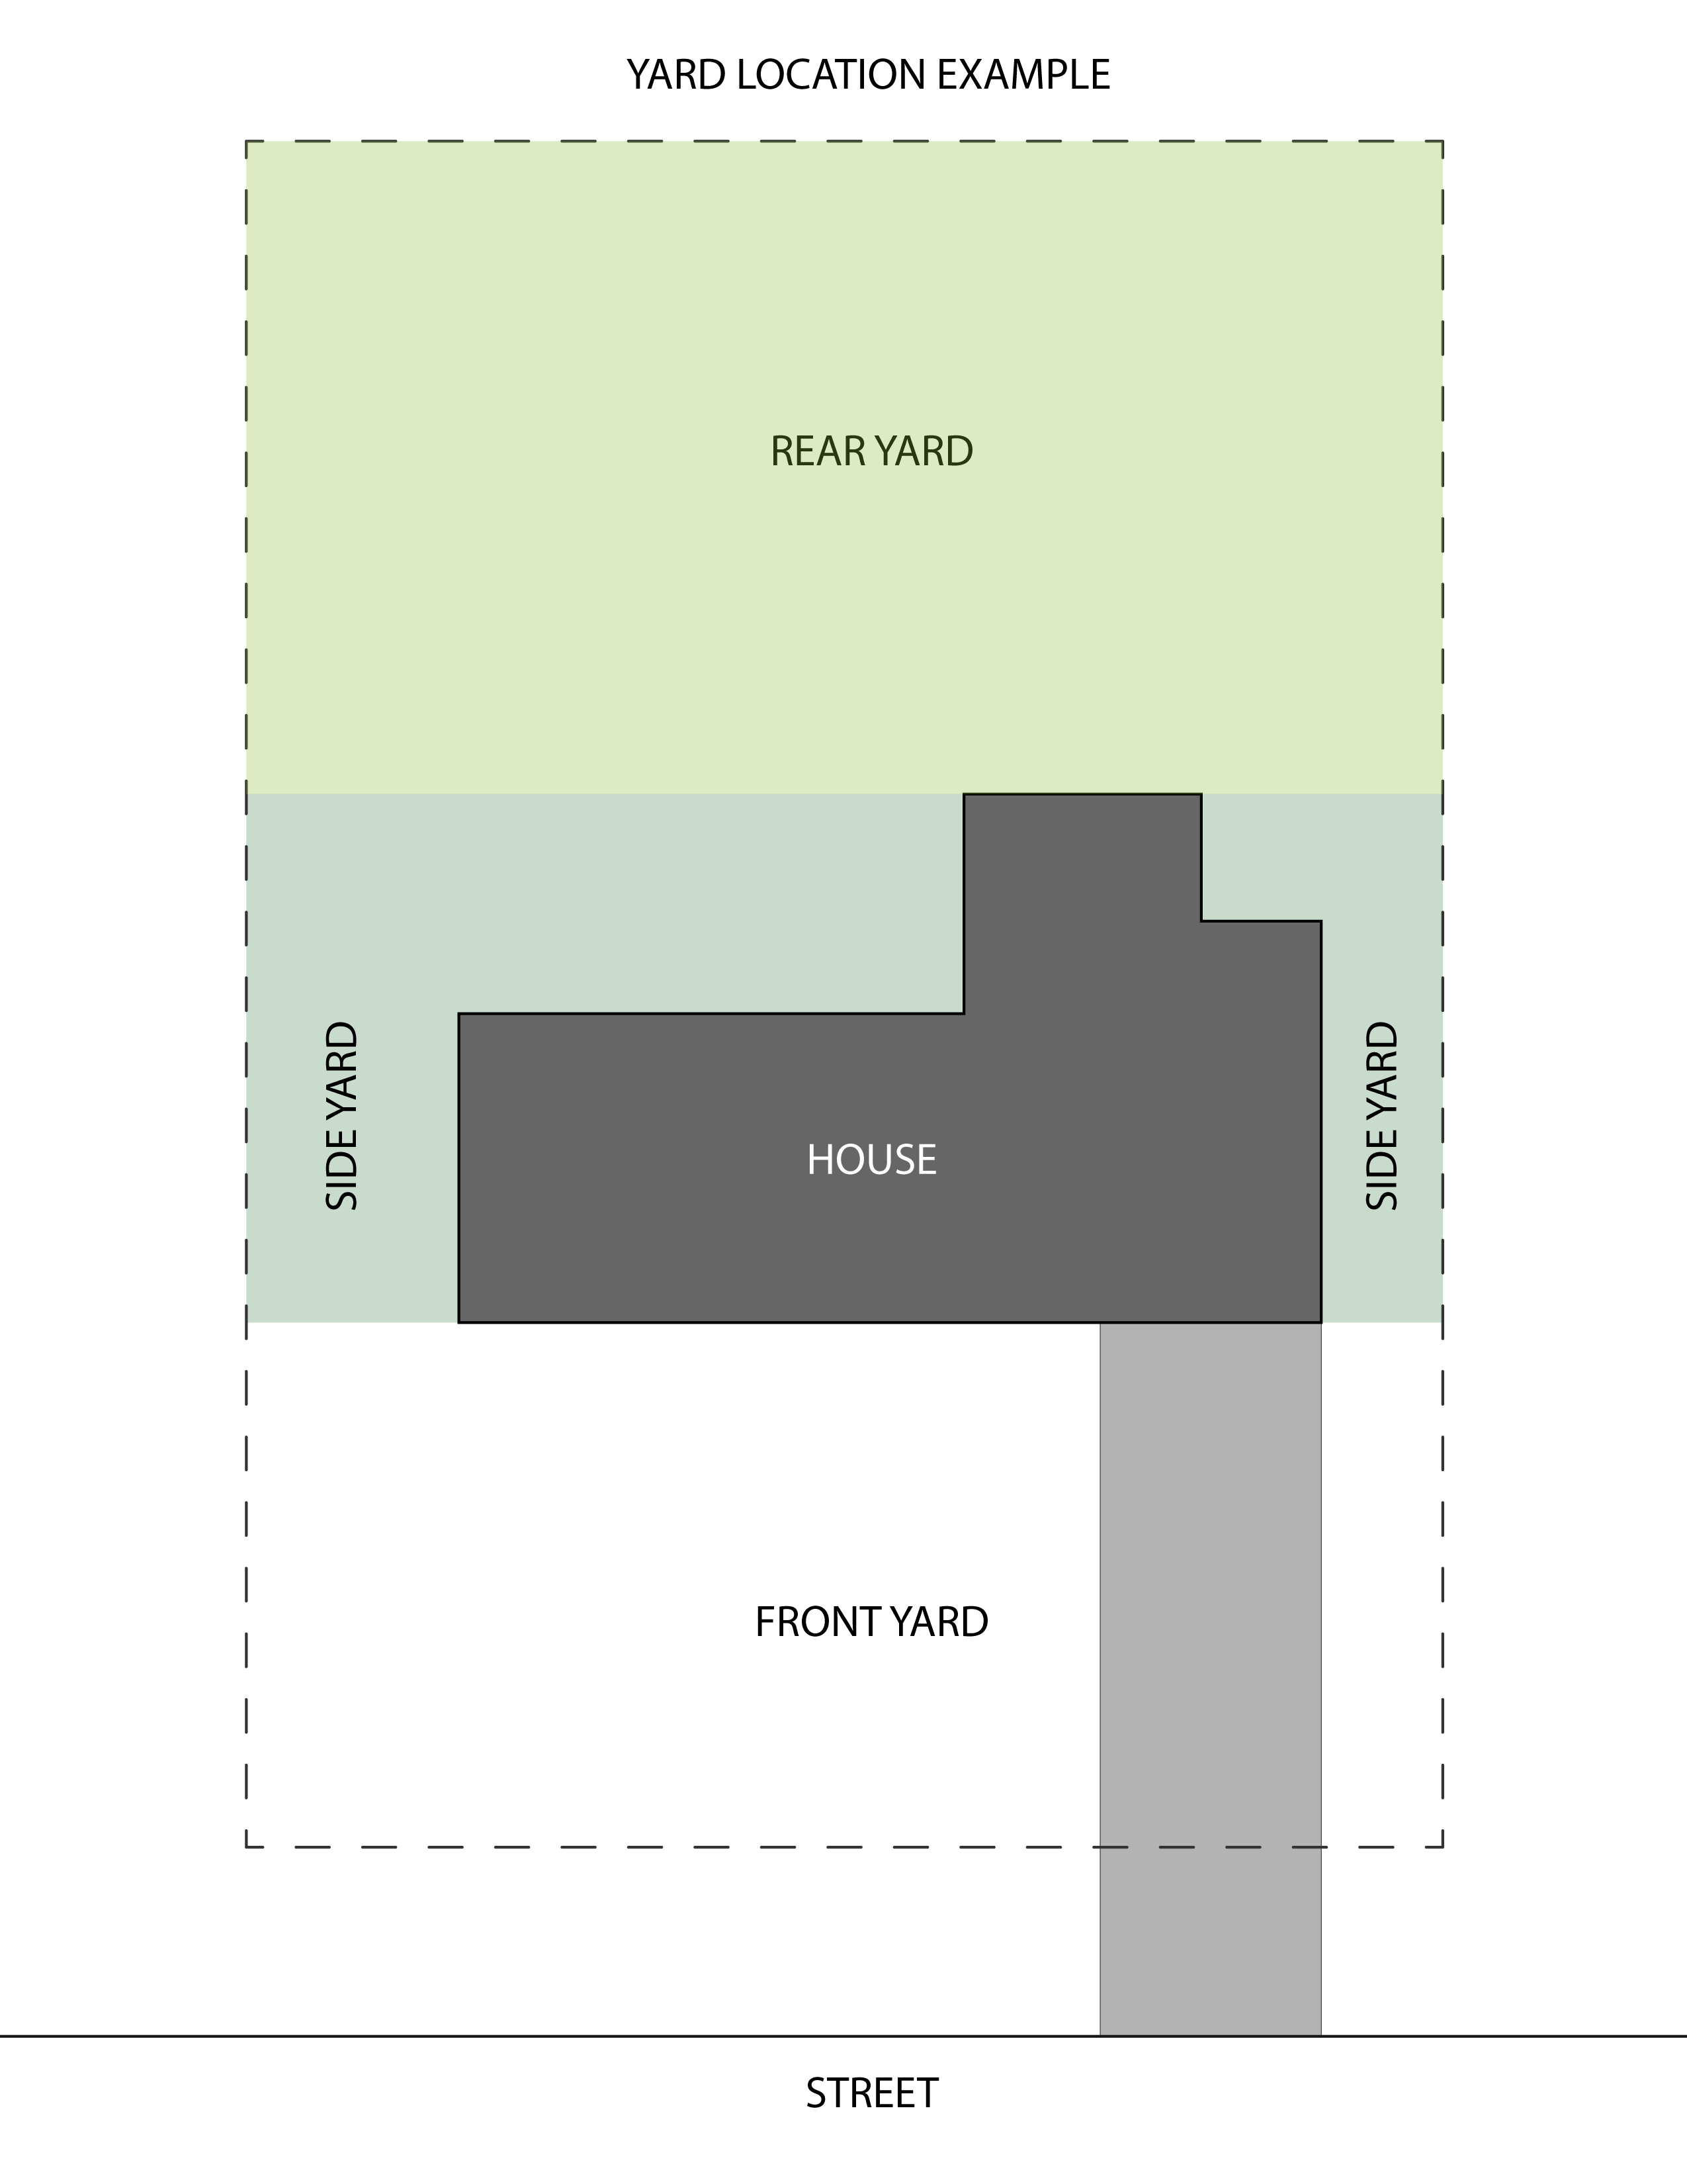
A site plan is required and should include a drawing of the lot drawn to scale on a sheet of paper not less than 8½" × 11" inches which contains: the location of property lines; location of structures, fences, existing drainage patterns and paved areas; location of each natural landscaping area; a list by scientific and common name of species intended to be planted and maintained within each area; and the setback distance of each natural area that will be located near any property line.
Any proposed soil amendments and levels of shade and sunlight should also be included on the plan, if possible. Although the actual conditions and layout will likely vary dramatically from property to property, the basic elements of the example can be applied to most projects (i.e. north arrow, scale, property lines, etc.).
Selection of native plant species that are suitable for the type of soil, soil moisture, sunlight, on the property as well as providing the desired aesthetic appearance is critical for success. For instance, a property with full sun and rich soils can be planted as prairie with a combination of grasses and bright colorful forbs. A wooded habitat with dry, well drained soils can be planted with spring woodland or savanna species. An area with poorly drained soils can be planted with wetland species. Understanding the property’s environmental conditions will help define the most appropriate planting area and design a successful naturalized landscape that the property owner will enjoy.
Naturalized landscaping provides opportunities to select a diverse variety of plants suitable for the site that will bloom throughout the year. Although they are not as colorful, it is important to include a variety of grass species in your planting as they contribute to the health of the naturalized landscape, provide root structure to help prevent weed growth and provide late fall and winter cover and visual interest. Plant spacing will depend on how much the plant will spread and grow out. A general rule of thumb that is often followed is to plant plugs twelve (12) inches to eighteen (18) inches on center. If establishing vegetation by seed, use a seed mix that includes a diverse combination of native forb and grass species using a minimum of twelve (12) to sixteen (16) pounds per acre. A cover crop of “annual” rye and oats are also typically included in a seed mix to minimize competition from undesirable species during the first year of establishment. Do not use perennial rye since this will compete with your native perennial species and is very difficult to eliminate once planted.
2. Removal of Existing Vegetation
The establishment of a naturalized habitat consisting of native plants that exceed twelve inches (12") in height including ferns, grasses, sedges, rushes, forbs, shrubs and trees is allowed under the Land Development Code. This is an intentional process and does not refer to allowing lawns or weeds to “go natural” on their own. Therefore, under most conditions the existing non-native vegetation must be eliminated in order to successfully plant the native vegetation through transplanting live plants or by seed.
Existing vegetation can be eliminated by physical removal, smothering, or chemical treatment. Physical removal is the most labor intensive option and can be accomplished by using tools such as a sod cutter, shovel or mechanical equipment to cut the turf below the root zone. Smothering is less labor intensive but can take a full growing season (5 to 6 months) to kill the turfgrass. Examples of smothering include covering the proposed planting area with materials such as black plastic sheeting, tarps, cardboard and mulch, used construction materials like sheetrock or plywood, used carpeting, or other opaque material. The key is to eliminate all sunlight for an extended period of time. The quickest method of turf elimination is the use of non-specific, short-duration chemical herbicides such as glyphosate. Because glyphosate affects metabolism in plants but not animals, it has very low toxicity to humans. Although it is possible to use these chemicals safely, it is extremely important to carefully follow manufacturer’s directions for use, especially when working near wetlands or water resources.
3. Installation
Native landscaping relies on the plant species that have lived in our region for thousands of years and have evolved to local growing conditions including climate, soils, precipitation and wildlife. Therefore, whenever possible it is recommended to utilize native plants and seed that are derived from local genetic sources, typically from within a 150 mile radius. These plants are commonly referred to as a “local genotype”. The use of local genotypes helps ensure the plants will perform optimally and require the least amount of supplemental watering or management. There are many nurseries, native plant retailers, and native plant sales that are able to provide native species from local genotypes.
Native herbaceous vegetation can be established using live plugs, potted plants or seed. Using live plugs or potted plants can be more costly than seed but provides the fastest establishment of a native landscape. Plugs are small rooted plants that typically become established in weeks rather than months (as by seed) and can reach a flowering size in the first year. Plants may also be available in quarts or gallon sizes to provide a more immediate aesthetic appearance. This can be particularly useful in high visibility or high traffic areas. Seed can be the least costly installation method and can be particularly useful for planting large areas. However, establishment by seed may require additional soil preparation, specialized equipment and can take two to three years to develop the appearance of a naturalized landscape. Other benefits of plugs are that they are easy to identify and weed around and provide greater control over the placement of species.
4. Management
When properly planted and established, naturalized landscapes are low maintenance compared to conventional landscaping. However, this does not mean “no maintenance”, especially during the first few years after planting. Native plants spend the first two to three years developing roots and typically require watering and weeding until their deep roots are established. If it does not rain, water plants weekly over the first year making sure to allow the water to soak deep into the soil. Once the roots are established, additional watering will not be needed. Fertilizing of native plants is not required at all. In fact, adding fertilizer provides an advantage to non-native or invasive plant species and actually encourages the growth of undesirable weeds. Therefore, a homeowner would be paying for fertilizer they don’t need and paying even more to correct the problems created by the fertilizer. Although native vegetation also does not require the application of pesticides, a limited amount of herbicide may be necessary to control invasive species as part of the long-term management of a naturalized landscape.

a. Short-Term
Annual weed species often dominate a new planting. The weed species can be controlled by hand-pulling, mowing or spot spraying/hand-wicking with herbicide. The early identification and elimination of undesirable species is the most effective form of control. Therefore, it is important to develop good plant identifications skills for the plants you want to keep in the landscape and those you do not. High mowing should be timed and performed to eliminate or prevent the development of seed heads and the production of seed from undesirable species while avoiding damage to desirable species. For instance, native species tend to be shorter than the non-native weeds during the late spring. Therefore, the height of a mower can be set above the native vegetation to cut as low as possible without injuring the native species (typically about 8 inches). Otherwise, a hand held weed-eater or hand scythe can be used to target and cut undesirable species close to the ground or to cut higher when in close proximity to native vegetation. By the second or third year the native plants will be more established and weeding will become minimal as the native landscape matures.
b. Long-Term
Long-term maintenance will likely require a combination of spring mowing, hand-pulling, spot-herbicide applications and supplemental planting. Prior to European settlement, periodic fires were a natural occurrence in the region so many of our native plants and ecosystems evolved to be dependent on fire. Therefore, controlled burns are a common tool for managing natural areas including prairies, wetlands and forests. Residents interested in utilizing controlled burns will need to comply with all state and local regulations and may wish to hire a professional that specializes in natural resource management. Since controlled burns may not be appropriate management tools for suburban areas, annual fall or spring mowing can be used to replace many the benefits of fire in naturalized landscapes on residential properties. Mowing should be performed in the late fall or early spring, before the start of the growing season, at a height of approximately6 to 8 inches. This will remove the previous year’s growth, allow sunlight to reach the ground, promote healthy vegetation growth, and maintain a neater appearance. To prevent smothering, thatch material will likely need to be collected and removed from the naturalized landscape. Landscape material can be composted on-site or removed through the Villages’ Yard Waste program. Waste Management provides Orland Park residents with yard waste collection from April 1 to November 30 using the proper paper collection bags or carts. Contact Waste Management of the South Suburbs at 800-796-9696 for more information.
Invasive species are plants, animal or fungus species that are not native to a specific location, which have the tendency to spread aggressively, and are believed to cause damage to the environment, human health, or human economy. Owners of naturalized landscapes must continuously monitor the habitat for invasive plant species since they spread rapidly in today’s landscape and can quickly degrade a naturalized area. Early identification and eradication is the most cost effective form of invasive species management since undesirable plants are not allowed to establish or go to seed. In most cases the invasive plant can simply be pulled out by hand. However, certain species such as common buckthorn (Rhamnus cathartica), Amur honeysuckle (Lonicera maacki), Tartarian honeysuckle (Lonicera tartarica), cut-leaved teasel (Dipsacus laciniatus) or common reed (Phragmites australis) may require a combination of cutting and herbicide treatment. Property owners may want to refer to organizations such as the Midwest Invasive Plant Network at www.mipn.org for more information including species identification and proper eradication methods.
Over time, residents may wish to increase the species diversity of the naturalized landscape area. This can be accomplished by transplanting live plants or adding native seed. Live plants or seed may also need to be added to areas where planted species have not been successful or the eradication of weeds has left bare patches. The addition of new plants can increase the biodiversity of the habitat, attract new species of wildlife (i.e. species of butterflies, birds, etc.) and help to prevent the development of bare spots by maintaining full coverage.
5. Monitoring
A properly installed naturalized planting will provide an aesthetically attractive, environmentally beneficial low maintenance landscape. After the naturalized landscape has initially been established, residents should continually monitor the habitat to protect their investment and ensure the naturalized landscape will continue to provide enjoyment. The intent of the Single-Family Residential Naturalized Landscaping ordinance is to promote the use of native plants and natural habitat on residential properties while avoiding the pitfalls that can occur from poor implementation or communication. In order to comply with the Ordinance a property must be inspected by a Village inspector or designee annually, or as determined by the Development Services Department, and the following performance criteria must be met:
a. By the end of the third growing season at least 90 percent of the planted naturalized landscape area, visually estimated by aerial cover, shall be covered with live vegetation.
b. By the end of the third growing season at least 70 percent of the vegetation in the planted naturalized landscape areas shall be plant species native to the Chicago Region.
c. None of the three-most dominant species present may be non-native or weedy, including but not limited to the following:

Woody Plants
Acer negundo Box elder
Alnus glutinosa Black Alder
Elaeagnus umbellata Autumn olive
Euonymus alatus Burning bush
Lonicera spp. Honeysuckle
Rhamnus spp. Buckthorn
Robinia pseudoacacia Black locust
Rosa multiflora Multiflora rose
Ulmus pumila Siberian elm

Broadleaf Plants
Alliaria petiolata Garlic mustard
Ambrosia spp. Ragweed
Arctium spp. Burdock
Carduus nutans Musk thistle
Centaurea maculosa Spotted knapweed
Cirsium arvense Canada thistle
Conium maculatum Spotted hemlock
Coronilla varia Crown vetch
Daucus carota Wild carrot
Dipsacus spp. Teasel
Euphorbia escula Leafy spurge
Hesperis matrionalis Dame’s rocket
Lotus corniculatus Bird’s-foot trefoil
Lythrum salicaria Purple loosestrife
Medicago spp. Alfalfa/medick
Melilotus spp. Sweetclover
Pastinaca sativa Wild parsnip
Polygonum cuspidatum Japanese knotweed
Solidago altissima Tall goldenrod
Solidago sempervirens Seaside goldenrod
Trifolium spp. Clover
Typha spp. Cattails

Grass-like Plants
Agropyron repens Quackgrass
Bromus tectorum Cheatgrass
Bromus japonicus Japanese brome
Bromus inermis Smooth brome
Phalaris arundinacea Reed canarygrass
Phragmites australis Common reed
Poa pratensis Kentucky bluegrass

d. If any of these criteria are not met, a remedial action plan shall be prepared that specifies a proposed course of action to bring the naturalized landscape area into compliance.
e. These criteria shall be maintained in perpetuity.
Upon installation of a naturalized landscape area, the site shall be inspected by a Village inspector or designee to verify compliance with the approved landscape plan and proper maintenance of the natural landscape area. After a successful inspection, the property owner will be provided with a letter from the Village certifying that the naturalized landscape has been inspected and meets the criteria of the Village Ordinance. Permission for single-family residential natural landscaping may be revoked with cause, such as failure of the owners to manage the areas or to respond to notices of creation of a nuisance or violation of the weed control ordinance, as determined by the Development Services Department.

6. APPROVAL

VILLAGE OF ORLAND PARK PETITIONER/OWNER

Approved By:_________________________ Submitted By:___________________________

Printed Name:__________________ Printed Name:___________________________

Title:_________________________ Property Address:___________________________

Date:_________________________ Contact Phone:_____________________________

Contact Email:_________________________

Date:_________________________

Land Development Code Section 6-305.F.2.c

- Single-Family Residential Naturalized Landscaping. Single-family residential properties that include naturalized landscaping areas that exceed twelve inches (12") in height are exempt from the letter of credit requirements detailed in 6-305.F.2.c Letter of Credit, although a Landscape Plan and an abridged Monitoring and Management Plan are still required. The following conditions apply to naturalized landscaping on single-family residential properties:

  - A property owner shall apply to the Development Services Department and receive a written approval of the landscape plan prior to the installation of the naturalized landscaping. The application shall include a plat of survey and a site plan of the single-family lot drawn to scale on a sheet not less than eight and one-half inches by eleven inches (8½" × 11"), which contains: the location of property lines; location of structures, fences, existing drainage patterns, and paved areas; location of each natural landscaping area; a list by scientific and common name of species intended to be planted and maintained within each area; and the setback distance of each naturalized landscape area that will be located near any property line. Any proposed soil amendments and levels of shade and sunlight should also be included on the plan.

  - It shall be permitted to grow native plants that exceed twelve inches (12") in height within a natural landscaping area, including ferns, grasses, sedges, rushes, forbs, shrubs and trees, in lieu of turf grass lawn in designed and managed natural landscape areas.

  - It is not the intent of this section to allow vegetated areas to be unmanaged, overgrown, a health hazard or a breeding ground for fauna known to create a safety or health hazard. Plant species that are defined as noxious and/or invasive by the Illinois Department of Natural Resources, Midwest Invasive Plant Network, or Illinois Invasive Species Council do not come within the protection of this section.

  - Natural landscaping shall be permitted in rear or side yards only, and setback at a minimum of three (3) feet of any property line. No setback shall be required where the natural landscaping is separated from adjacent lots by fencing or continuous shrub of three (3) feet or more in height, or where the natural landscape area abuts permitted naturalized landscaping on an adjacent lot.

  - Naturalized landscaping may occupy a maximum of thirty percent (30%) of the total existing open space within the side or rear yards of a single-family residential property.

  - If the naturalized landscape installation would affect natural drainage or involve earthwork or affect capacity of neighboring retention or detention facilities, then a land development review application shall be submitted as per the provisions of Title 5 of the Village’s Land Development Code.

  - A plan for the near- and long-term maintenance of the naturalized landscape area shall be submitted for review and approval. The Village document, commonly referred to as “Monitoring and Management Plan for Naturalized Vegetation Areas on Single Family Residential Properties”, as amended, shall be used as a template for the completion of a single-family residential naturalized landscape Monitoring and Management Plan. Minor edits to this template may be made by the petitioner; however, the final text of the M&M Plan shall be approved by the Development Services Department.

  - Upon installation of a naturalized landscape area, the site shall be inspected by a Village inspector or designee to verify compliance with the approved landscape plan and proper maintenance of the natural landscape area. Subsequent inspections shall be performed annually by the Village or designee, or as determined by the Development Services Department.

  - Permission for single-family residential natural landscaping may be revoked with cause, such as failure of the owners to manage the areas or to respond to notices of creation of a nuisance or violation of the weed control ordinance.

