February 13, 2023

Dear Neighbor of Kingsport Natural Area:

This notice is to inform you that the naturalized areas at Kingsport Natural Area, located west of 108th Ave., east of Coleman Dr. and south of Bear Island Ave. in Orland Park, Illinois, will be subject to a prescribed burn between February 21st, 2023 and May 15, 2023, weather permitting. Alternately, should the burn require rescheduling due to unfavorable weather, a prescribed burn will occur on one to two days between November 1, 2023 and May 15, 2024.

The prescribed burning will be conducted in a safe and expeditious manner by trained and experienced personnel of V3 Companies. The burn plan calls for quick dispersal of the smoke. This activity is permitted by the Illinois Environmental Protection Agency and jurisdictional fire department.

The purpose of the burn is to improve the native plant communities by reducing the non-native shrubs and weeds that invade the prairie areas and degrade these natural communities. Conversely, prescribed burning also promotes the germination and growth of many native plant species that are adapted to and require periodic fire to maintain healthy natural communities. Prescribed burning is a technique widely used for the restoration and management of natural areas throughout the Midwest.

If you have any questions or concerns about this activity, please contact Brad Millis at 630-729-6256.

Sincerely,
V3 COMPANIES
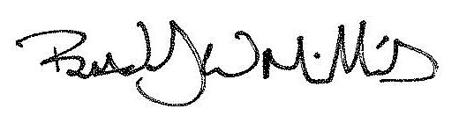
Brad Millis
Project Manager II
AKP/ll

